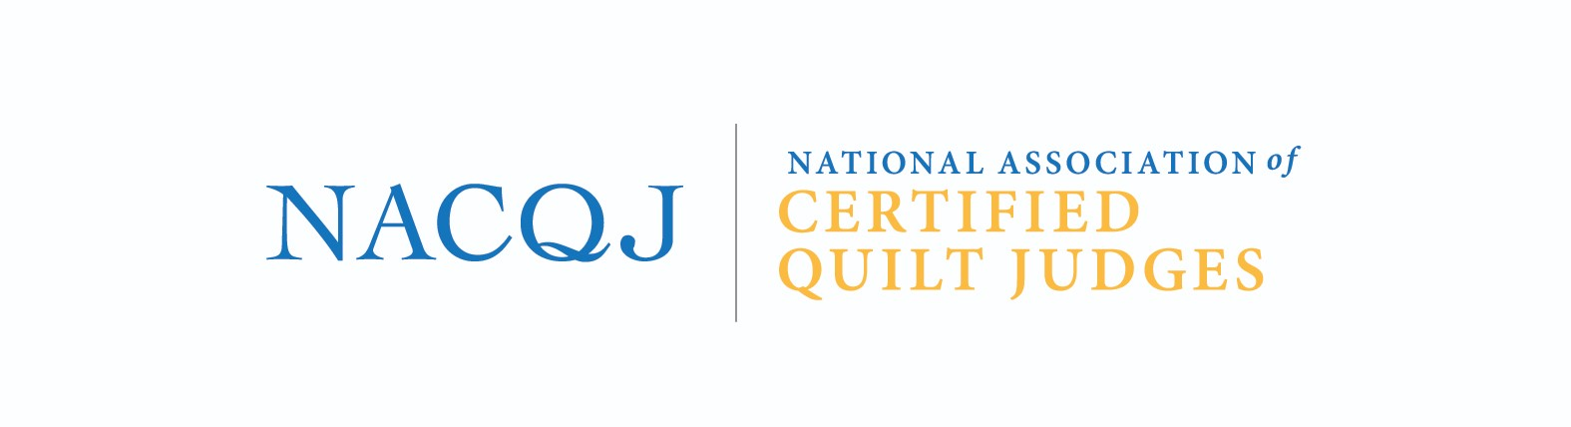

NACQJ Certification Update Policy Statement
NACQJ Certified Quilt Judges are committed to the continual growth of the Certified Quilt Judges program. The integrity of the NACQJ Certified Judge designation is maintained through commitment to the update process. Completing the annual update serves as a good accountability review for each individual certified judge. It provides the organization with general statistics about the activity of the organization’s members. It gives the Certified Judge Coordinator and the Board of Directors helpful information for professional development opportunities. The update provides each certified judge an opportunity to indicate a desired level of membership for the following year.
Certified judges will be expected to complete the annual update form and submit it to the Certified Judges Coordinator by January 31st, using information from the prior year. This form can be used at any point during the year to change membership levels, update addresses, or other information. The update form should be submitted along with annual dues, a signed copy of the Code of Conduct and Code of Ethics.
As stated on the form, Certified Judges are acknowledging that their participation within the organization is not only welcomed but required. Certified Judges agree to attend a partner show once every three years and present information on a quilt judging related topic or technique every three years. The presentation of information can be verbal or written, and the presentations can be given at partner shows, conferences, during a Zoom meeting or in the newsletter. The presentations will be peer reviewed for educational benefit and/or judging benefit. The board may grant an exception to the requirement if other participation contributes to the organization. Reading paperwork and sitting on a panel will not count towards this participation contribution. Examples include being webmaster or newsletter editor.
Revised 1.2023 by KE
Revised 1.2023 by SC
Revised 10.2023 by SC

